# **BTD310- Lab 5**

Please work in **groups** to complete this lab. This lab is worth 2% of the total course grade and will be evaluated through your written submission, as well as the lab demo. During the lab demo, group members are randomly selected to present the answers to each of the lab questions. Group members not present during the lab demo will lose the demo mark.

Please submit the following files through Blackboard. Only one person must submit for the team.

* Lab5.sql must include a script including all the SQL commands for the following. Please write them in the specified order.
* Lab5.txt must be the output of the above script. Use the save button on top of the script results.

1. Create a new SQL worksheet in SQL Developer, save as **Lab5.sql**, and write SQL statements to do the following. DO NOT USE SUBQUERIES UNLESS SPECIFIED.
2. (a) How many employees have the letter Z in their last name?

(b) In how many distinct locations are the departments located? Use data from the DEPARTMENTS table.



1. How many employees are there in each phone area code? Sort by area code.

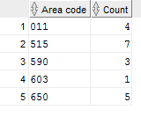

1. How many locations do NOT have postal codes starting with a number? Hint: Note the NULL values.



1. Find the mid-point between the lowest and highest salaries of each department that all their employees have salaries higher than $5000. Sort by department ID and do not include null for the department_id. Hint: Use the EMPLOYEES table.

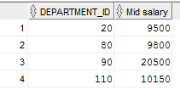

1. The company wants to give a BONUS OF $1000 to employees who don’t earn commissions and $500 to those who do earn commissions. What is the total bonuses that each department will be paying out? Do not include the null row.

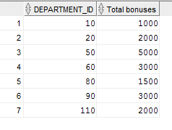

1. Use a join to list the address of each department that is not located in Seattle in the following format:

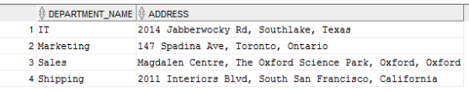

1. Use a self join to list employees’ managers and phone numbers. Sort the list y manager IDs, as shown:

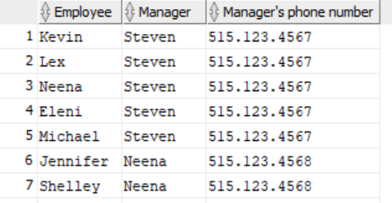

1. List all employees that have last names coming after ‘Hartstein’ in an alphabetically sorted list, but have employee IDs that come before Hartstein’s ID. Use a subquery to look up Hartstein’s ID. (do not hard-code this value.) Sort by last name.

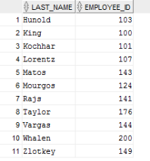

1. Do the previous question without subqueries. Instead use a self cross join.
2. Similar to question 2, but this time find the percentages (count divided by the total number * 100). Sort by the percentages. Hint: You can use a subquery to return the total number of rows.

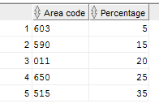

1. Add a comment before each answer to specify the question number. For example,

-- Question 3

1. Use SQL Developer to format your script.
2. Clear the script output. Then run your script (F5). Save the output as **Lab5.txt**.
3. Add this declaration on the top of your Lab5.txt file.

We, ------------(mention your names), declare that the attached assignment is our own work in accordance with the Seneca Academic Policy. No part of this assignment has been copied manually or electronically from any other source (including web sites) **or distributed to other students.**

1. Also, on top of Lab5.txt, specify what each member has done towards the completion of this work:

Name Task(s)

1-

2-

3-